1. Touch filename.sh
2. Vim filename.sh
3. Cat filename.sh
4. Gedit filename.s
5. Ls –l
6. ./filename.sh
7. To fprint contents in file we “ >> filename”
8. Else we van use head –n filename(source) >> filename(destination)
9. <<COMMENTS …. >> #comments the lines

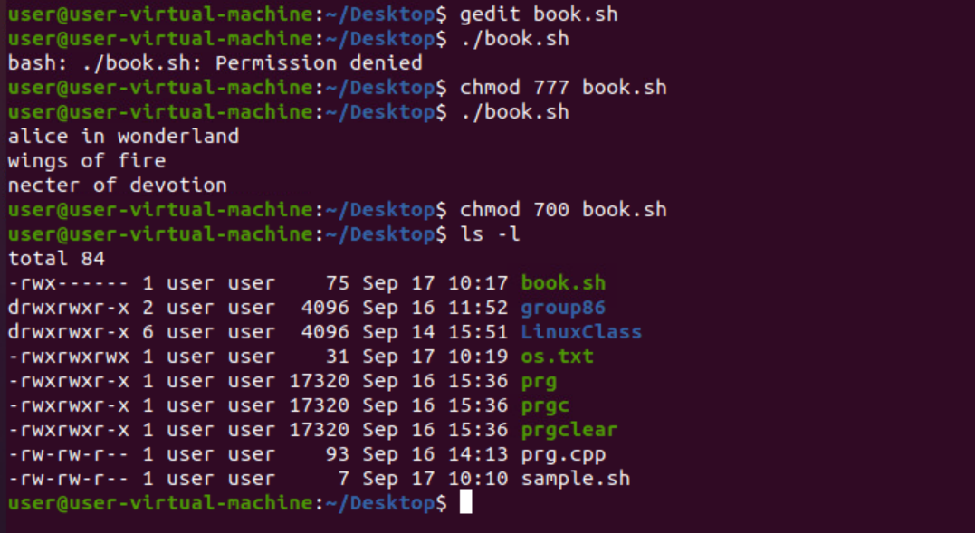

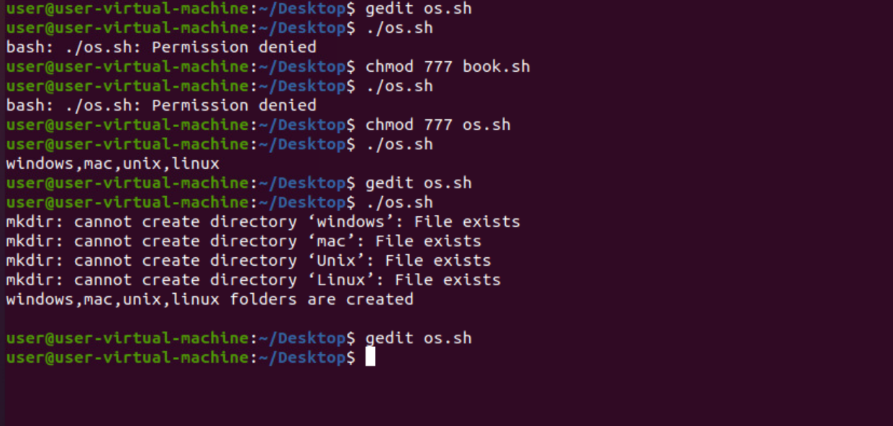

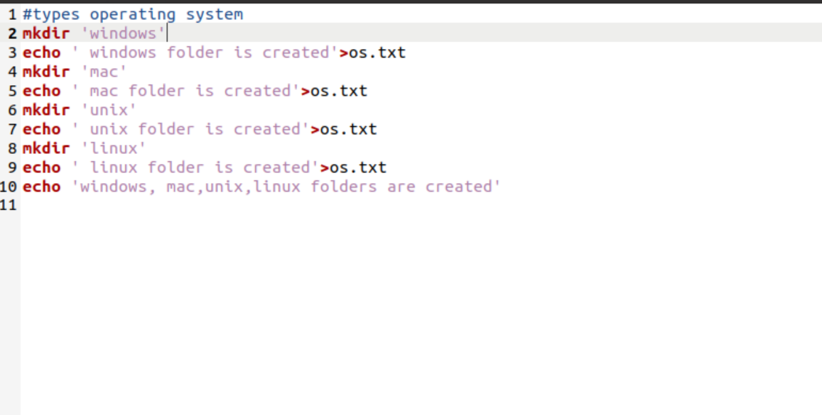

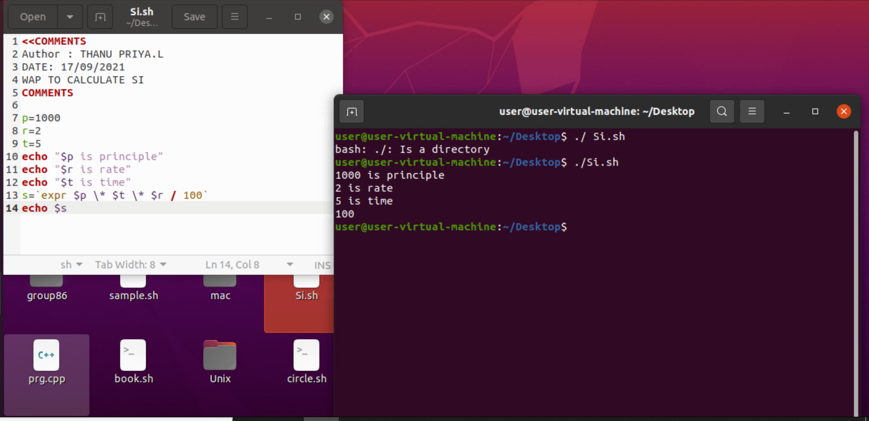

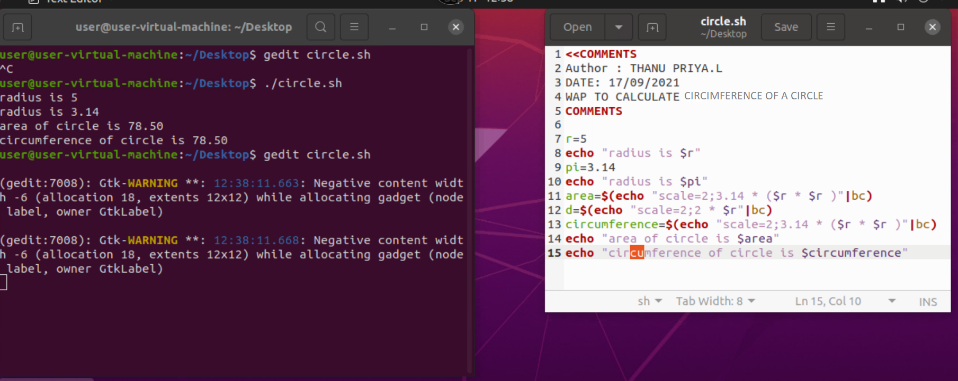

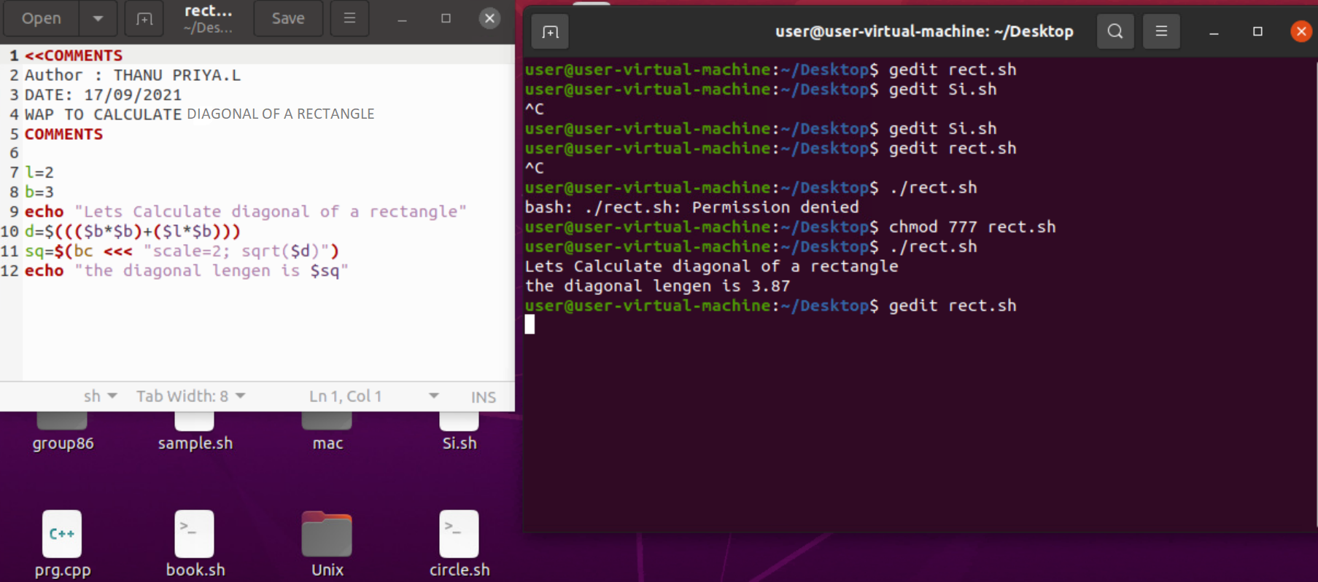

|  |
| --- |
| **Shell Script to print half pyramid using**  rows=4  for((i=1; i<=rows; i++))  do  for((j=1; j<=i; j++))  do  echo -n "* "  done  echo  Done  **Shell Script to print inverted half pyramid using numbers**  number=1  rows=5  for((i=rows; i>=1; i--))  do  for((j=1; j<=i; j++))  do  echo -n "$number "  number=$((number + 1))  done  number=1  echo  Done  **Shell Script to print multiple table using user given number**  echo "Enter a Number"  read n  i=0  while [ $i -le 10 ]  Do  echo " $n x $i = `expr $n \* $i`"  i=`expr $i + 1`  done |